Cardiovascular Health in teenagers

Introduction:

Your heart and the blood arteries that transport blood around your body are part of your cardiovascular system. Your heart pumps blood throughout your body, delivering important oxygen and minerals (Healthy WA, 2022). It's critical to live a healthy lifestyle if you want to keep your heart healthy. This involves eating a balanced diet and exercising regularly. Any movement that requires your body to burn calories is considered exercise. Exercise not only has health benefits, but can benefit you both physically and mentally.

Exercise has a significant impact on your resting heart rate. The number of times your heart beats in one minute is called your heart rate. Resting heart rate is how many heart beats you have per minute when you aren’t exercising or otherwise under stress. For teenagers, a normal resting heart rate is 60 to 100 beats per minute. Generally, a lower heart rate at rest implies more efficient heart function and better cardiovascular fitness. Exercise strengthens the heart muscle. It allows it to pump a greater amount of blood with each heartbeat. More oxygen is going to the muscles. This means the heart beats fewer times per minute than it would in someone who does not exercise regularly. Your physical fitness is directly correlated to the strength of your heart (Healthline, 2022). However, there are a lot of other factors that impact resting heart rate like age, body size, air temperature (on hot or humid days, heart rate may increase), emotion, heart conditions and medication use.

This investigation aims to find out the effects of exercise on heart health.

Hypothesis:

It is hypothesized that during this investigation the participants/ teenagers who exercise more regularly will have lower heart BMP (beats per minute) and are healthier than participants/ teenagers who exercises less regularly.

Variables:

The independent variable in this investigation was the amount of exercise the participants did weekly.

The dependent variable in this investigation was the heart rates of the students.

The controlled variable in this investigation was the age range of the participants (15 years-17years), the method acquiring the data and the participants were resting.

Materials:

* Timer x1
* Teenage participants (ages 15-17) x25
* Calculator x1

Method:

Step 1: Create the table (subheadings from left to right): subject, exercise (days/week), resting heart rate BMP (beats per minute) trials 1, trial 2 , and trial 3, average BPM, sex.

Step 2: Before you begin testing, make sure your participant is seated for at least 5 minutes.

Step 3: Place your index finger and middle finger on the pulse of participant 1 and begin timing (count the heart beats over 30 seconds)

Step 4: To get the BMP (beats per minute), multiply the value by two and record in table.

Step 5: Do steps 2 through 4 twice more and find the average of that participant’s BPM, record this result.

Step 6: Record the sex and “days of exercise per week” of that participant.

Step 7: Do steps 2 through 6 for all 25 participants.

Step 8: Take the average of scores of each category of “days of exercise per week” and record these results and graph it.

Results:

Figure 1.1

|  |  |  |  |  |  |  |
| --- | --- | --- | --- | --- | --- | --- |
|  |  | Resting Heart Rate (beats/minute) | | |  |  |
| Subject | Exercise (days) | 1 | 2 | 3 | Average | Gender |
| 1 | 2 | 70 | 72 | 68 | 70 | F |
| 2 | 2 | 76 | 70 | 70 | 72 | F |
| 3 | 3 | 66 | 68 | 66 | 67 | F |
| 4 | 3 | 66 | 62 | 72 | 67 | F |
| 5 | 1 | 96 | 86 | 88 | 90 | F |
| 6 | 4 | 50 | 50 | 44 | 48 | F |
| 7 | 2 | 52 | 54 | 70 | 59 | F |
| 8 | 1 | 78 | 76 | 78 | 77 | F |
| 9 | 3 | 71 | 74 | 72 | 72 | M |
| 10 | 4 | 84 | 82 | 86 | 82 | M |
| 11 | 2 | 80 | 80 | 80 | 80 | M |
| 12 | 4 | 66 | 70 | 70 | 71 | M |
| 13 | 5+ | 94 | 102 | 100 | 99 | M |
| 14 | 4 | 76 | 72 | 68 | 72 | F |
| 15 | 0 | 82 | 78 | 83 | 81 | M |
| 16 | 5+ | 50 | 45 | 72 | 56 | F |
| 17 | 1 | 66 | 68 | 64 | 66 | F |
| 18 | 1 | 68 | 64 | 64 | 65 | F |
| 19 | 2 | 70 | 72 | 72 | 71 | F |
| 20 | 5+ | 72 | 70 | 74 | 72 | F |
| 21 | 4 | 84 | 81 | 83 | 83 | F |
| 22 | 2 | 69 | 71 | 67 | 69 | M |
| 23 | 0 | 73 | 75 | 78 | 76 | F |
| 24 | 1 | 71 | 68 | 67 | 69 | M |
| 25 | 3 | 69 | 72 | 68 | 70 | F |

Figure 1.2

|  |  |
| --- | --- |
| Exercise Group (days/week) | Average Resting Heart Rate (beats/minute) |
| 0 | 79 |
| 1 | 73 |
| 2 | 70 |
| 3 | 69 |
| 4 | 71 |
| 5+ | 76 |

Figure 1.3

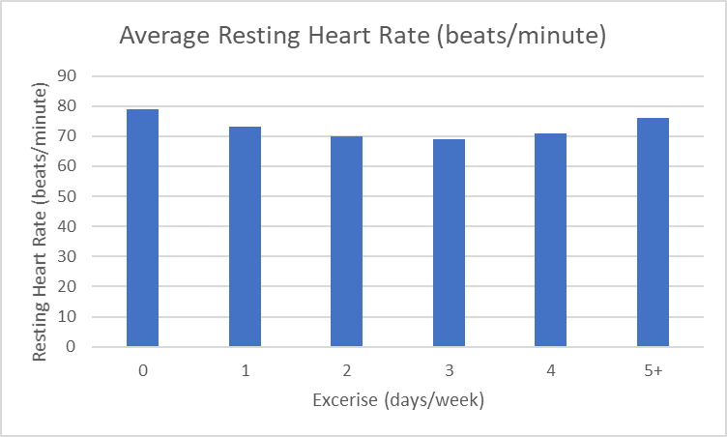

Reference:

* Healthy WA, (2022). Retrieved 22 March 2022, from <https://www.healthywa.wa.gov.au/Health-conditions/Heart-health-cardiovascular>
* Exercise: The Top 10 Benefits of Regular Physical Activity. (2022). Retrieved 22 March 2022, from <https://www.healthline.com/nutrition/10-benefits-of-exercise>
* Why Do Athletes Have a Lower Resting Heart Rate?. (2022). Retrieved 22 March 2022, from <https://www.healthline.com/health/athlete-heart-rate>